WIN Achieve 3000
Welcome to Mrs. Beaumont’s room!
Sault Middle School

Email: kbeaumont@eupschools.org
Room 801

Achieve 3000:
Based on decades of scientific research, Achieve 3000’s proven and patented method of online differentiated instruction engages all learners at their individual reading levels and constantly challenges them to improve their literacy skills. Our solutions steadily increase students’ ability to read, comprehend, apply, and communicate information derived from complex text.

The student receives differentiated, grade-appropriate, nonfiction passages, matched to their individual Lexile level. The student completes regular assessments, aligned to grade-level standards, which measure their ability to comprehend informational text. As the student progresses through their activities, their Lexile level is evaluated each month, and text rigor is increased when progress is detected.
Website: https://portal.achieve3000.com/

Expectations: Students will be expected to work on their articles and be on task. Article questions and comprehension questions will be required daily.

Classroom Rules:
Be Punctual- When the bell rings have all materials out and be in your seat ready to work.
Be Prepared- Bring all materials to class. Borrow materials or sharpen pencils BEFORE the bell rings.
Be Respectful- Follow all school and classroom rules. Respect the classroom materials. Respect your classmates and the teacher by not disrupting. Respect yourself by working your hardest.
Be Responsible- Turn all your work on time and check for absent work right away.
Be Organized- Know what materials you need and what is expected of you.
Be an Achiever- Try your best and aim for success. Don’t be afraid to ask questions.
Materials: A pencil and the student planner will be required on a daily basis. Planners will be checked each day. Students will be using an assigned classroom chromebook daily.

Entering the Classroom: Use hand sanitizer upon entering and wipe down the desk. Get your assigned computer number and bring it to your table.
Cell Phones: The use of cell phones is not permitted during class. Our class will be following the cell phone policy laid out in the student handbook. The handbook policy is below.
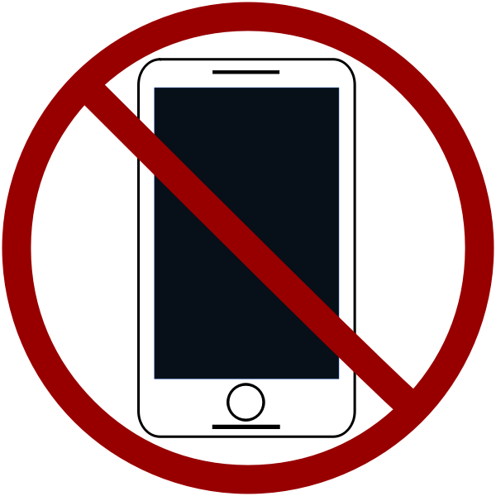
Sault Area Middle School respects family decisions to afford access to personal electronic devices to their students. To preserve the integrity of the academic learning environment, all personal electronic devices to include, but not limited to, Bluetooth enabled devices, earbuds/airpods, smart watches, and cellular devices are to be powered off and secured in backpacks/assigned lockers from 7am to 3pm. Personal electronic devices are not permitted to be carried or used while inside the school building, or during morning SPARK activities on the playground or in the gyms.

Students that violate the expectation that devices are powered off and secured in lockers will have the device(s) confiscated by school staff. Parents and/or guardians listed in MiStar will be able to pick up the device(s) from the main office from 3-4pm.

Sault Area Middle School strongly encourages families to refrain from sending students with personal electronic devices to school.

Chromebooks:
Students will be working on Chromebooks on a daily basis. The following expectations will be required when using the Chromebooks.
- Treat the classroom Chromebooks with respect. Put them back in the cart in their assigned place and plug them in for the next person.
- Your Chromebook is for classroom purposes only. No gaming, chatting, or YOUTUBE unless specifically allowed.
- Stay on task.
- Make sure you follow directions and complete assignments as directed.
- If you have technical difficulties, ask for help.
- If you damage or interfere with the Chromebook’s ability to work, a fee will be assessed by the school district and a disciplinary referral may occur.

Tentative Weekly Schedule:
Note: This schedule applies to an average week of school and may be subject to change with school events or if you need extra help in a different class during WIN time.
Monday
- Do the “WIN Weekly Check-In”. This will tell me what projects/work you have coming up in other classes that you may need help in or extra work time to complete.
- 10-15 Minutes of SEL (Social Emotional Learning)
- Achieve 3000 work time & daily planner check
Tuesday
- 10-15 Minutes of SEL
- Grade Checks
- Achieve 3000 work time & daily planner check
Wednesday
- 10-15 Minutes of SEL
- Achieve 3000 work time & daily planner check
Thursday
- 10-15 Minutes of SEL (Social Emotional Learning)
- Achieve 3000 work time & daily planner check
Friday
- 10-15 Minutes of SEL (Social Emotional Learning)
- WIN work time & daily planner check
- If you have no work in other classes, you will be working to improve your computer skills on Learning.com.
Grading- Each student will be required to complete 2-3 Achieve articles per week. The articles average of the first and second attempt will be entered into the gradebook weekly. Students will have the opportunity for incentives when they get 100% on their first attempt on comprehension questions. At the end of the quarter, a credit or no credit grade will be assigned for following the article expectations.

PLEASE FILL OUT AND RETURN THE BACK PAGE

Parents/Guardians,

Please feel free to contact me if you have any comments/concerns. The best way to contact me is through my email at kbeaumont@eupschools.org. I check my email daily, so the response will be quick. You may also contact me by phone at (906)635-3839 ex: 5719. I would like to keep in contact with parents to make sure this year is successful.

Students will have work time on Fridays for projects. They will also have the opportunity to receive teacher help if they are struggling with specific assignments or subjects. If there is anything your student has coming up that you know they need help with, please contact me to let me know. This is a class for them to get extra help and to make as much growth as possible this year.

If you have any comments, questions, or concerns please leave them in the space provided below along with your email address or phone number and I will try to answer your questions as quickly as possible.

I would also greatly appreciate it if you could answer the questionnaire at the bottom of the page to ensure seamless communication this year. Thank you!

Parent signature: (Print)_______________________________________________
Parent signature: ____________________________________________________
Student Name: (Print)_________________________________________________
Student Signature: ___________________________________________________

PARENT COMMENTS/CONCERNS:

Questionnaire:
- Do you have internet access at home?_________ (Y/N)
- Is there anything you would like me to know about your child?
_________________________________________________________________________________________________________________________________________________________________________

